# Defect Life Cycle or a Bug lifecycle in software testing

Defect life cycle is a cycle which a defect goes through during its lifetime. It starts when defect is found and ends when a defect is closed, after ensuring it’s not reproduced.

The bug has different states in the Life Cycle. The Life cycle of the bug can be shown diagrammatically as 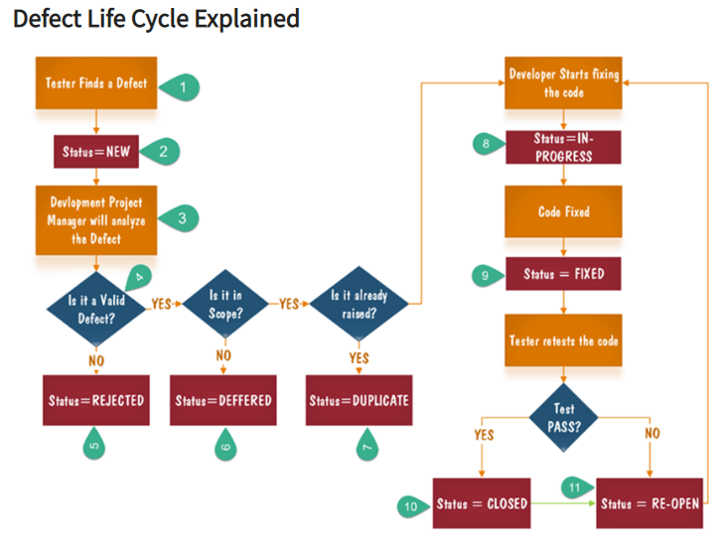

1. Tester finds the defect
2. Status assigned to defect- New
3. A defect is forwarded to Project Manager for analyze
4. Project Manager decides whether a defect is valid
5. Here the defect is not valid- a status is given "Rejected."
6. So, project manager assigns a status **rejected**. If the defect is not rejected then the next step is to check whether it is in scope. Suppose we have function- email functionality for the same application, and you find a problem with that. But it is not a part of the current release when such defects are assigned as a **postponed or deferred**status.
7. Next, the manager verifies whether a similar defect was raised earlier. If yes defect is assigned a status **duplicate**.
8. If not the defect is assigned to the developer who starts fixing the code. During this stage, the defect is assigned a status **in- progress.**
9. Once the code is fixed. A defect is assigned a status **fixed**
10. Next, the tester will re-test the code. In case, the Test Case passes the defect is **closed.** If the test cases fail again, the defect is **re-opened** and assigned to the developer.
11. Consider a situation where during the 1st release of Flight Reservation a defect was found in Fax order that was fixed and assigned a status closed. During the second upgrade release the same defect again re-surfaced. In such cases, a closed defect will be **re-opened.**

**Bug or defect life cycle includes following steps or status:**

**New:**  When a defect is logged and posted for the first time.

**Assigned:**  After the tester has posted the bug, the lead of the tester approves that the bug is genuine and he assigns the bug to corresponding developer and the developer team.

**Open:** At this state the developer has started analyzing and working on the defect fix.

**Fixed:** When developer makes necessary code changes and verifies the changes then he/she can make bug status as ‘Fixed’ and the bug is passed to testing team.

**Retest:**  At this stage the tester do the retesting of the changed code which developer has given to him to check whether the defect got fixed or not.

**Verified:** The tester tests the bug again after it got fixed by the developer. If the bug is not present in the software, he approves that the bug is fixed and changes the status to “verified”.

**Reopen:** If the bug still exists even after the bug is fixed by the developer, the tester changes the status to “reopened”. The bug goes through the life cycle once again.

**Closed:** Once the bug is fixed, it is tested by the tester. If the tester feels that the bug no longer exists in the software, he changes the status of the bug to “closed”. This state means that the bug is fixed, tested and approved.

**Duplicate:** If the bug is repeated twice or the two bugs mention the same concept of the bug, then one bug status is changed to “duplicate**“.**

**Rejected:** If the developer feels that the bug is not genuine, he rejects the bug. Then the state of the bug is changed to “rejected”.

**Deferred: The bug, changed to deferred state means the bug is expected to be fixed in next releases. The reasons for changing the bug to this state have many factors. Some of them are priority of the bug may be low, lack of time for the release or the bug may not have major effect on the software.**

**Not a bug:  The state given as “Not a bug” if there is no change in the functionality of the application.**

Difference between Severity and Priority

There are two key things in defects of the software testing. They are:

Severity

Priority

**1)  Severity**:

It is the extent to which the defect can affect the software. In other words it defines the impact that a given defect has on the system.**For example:** If an application or web page crashes when a remote link is clicked, in this case clicking the remote link by an user is rare but the impact of  application crashing is severe. So the severity is high but priority is low.

Severity can be of following types:

**Critical:**The defect that results in the termination of the complete system or one or more component of the system and causes extensive corruption of the data. The failed function is unusable and there is no acceptable alternative method to achieve the required results then the severity will be stated as critical.

**Major:**The defect that results in the termination of the complete system or one or more component of the system and causes extensive corruption of the data. The failed function is unusable but there exists an acceptable alternative method to achieve the required results then the severity will be stated as major.

**Moderate:**The defect that does not result in the termination, but causes the system to produce incorrect, incomplete or inconsistent results then the severity will be stated as moderate.

**Minor:**The defect that does not result in the termination and does not damage the usability of the system and the desired results can be easily obtained by working around the defects then the severity is stated as minor.

**Cosmetic:**The defect that is related to the enhancement of the system where the changes are related to the look and field of the application then the severity is stated as cosmetic.

**2)  Priority**:

Priority defines the order in which we should resolve a defect. Should   we fix it now, or can it wait? This priority status is set by the tester to the developer mentioning the time frame to fix the defect. If high priority is mentioned then the developer has to fix it at the earliest. The priority status is set based on the customer requirements.**For example:**If the company name is misspelled in the home page of the website, then the priority is high and severity is low to fix it.

Priority can be of following types:

**Low:**The defect is an irritant which should be repaired, but repair can be deferred until after more serious defect have been fixed.

**Medium:**The defect should be resolved in the normal course of development activities. It can wait until a new build or version is created.

**High:**The defect must be resolved as soon as possible because the defect is affecting the application or the product severely. The system cannot be used until the repair has been done.

**Few very important scenarios related to the severity and priority which are asked during the interview:**

**High Priority & High Severity**: An error which occurs on the basic functionality of the application and will not allow the user to use the system. (Eg. A site maintaining the student details, on saving record if it, doesn’t allow to save the record then this is high priority and high severity bug.)

**High Priority & Low Severity:**

The spelling mistakes that happens on the cover page or heading or title of an application.

**High Severity & Low Priority:**

An error which occurs on the functionality of the application (for which there is no workaround) and will not allow the user to use the system but on click of link which is rarely used by the end user.

**Low Priority and Low Severity:**

 Any cosmetic or spelling issues which is within a paragraph or in the report (Not on cover page, heading, title).